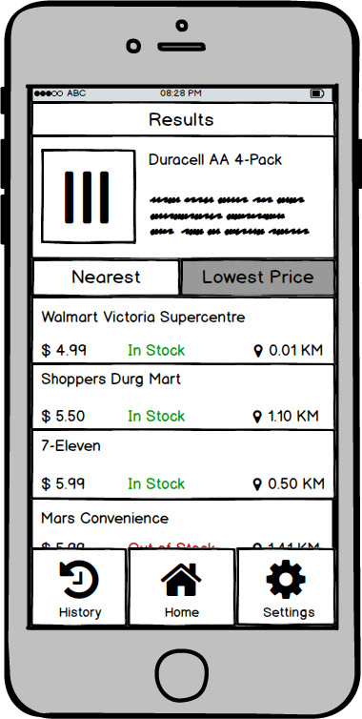

Nearest Lowest Price

**Walmart Victoria Supercentre**

**$ 4 aq In Stock Ο Ο.Ο1 KM Shoppers Durg Mart**

$5.50 In Stock 9 110 KM

**7-Eleven**

$ 5.aq In Stock Ο Ο.5Ο ΚM

**Mars Convenience**

**Settings**